Online course on “Everyday is a New Beginning for He Died for the Forgiveness of Sins-Love Yourself!”

Forgiveness-Matthew West
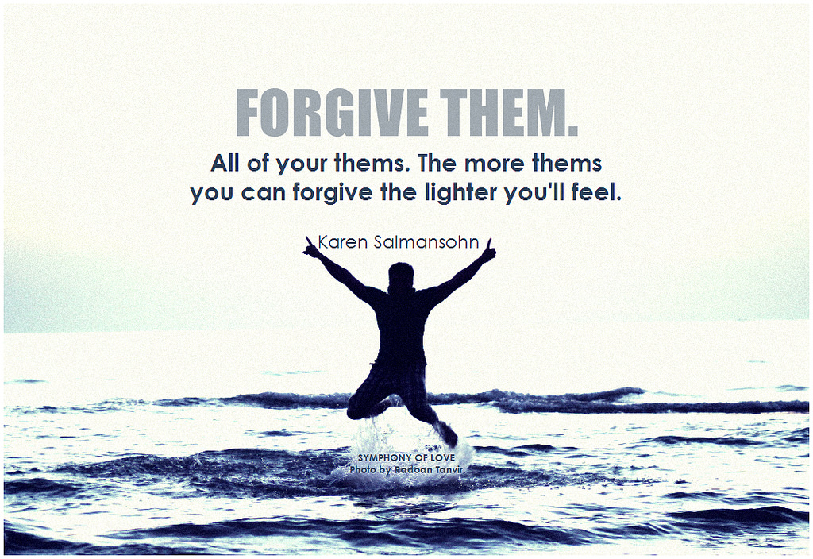

Welcome to this online experience where I hope peace and joy can be yours at the end. What a beautiful thought-the one above- Forgive all of them and the lighter you feel!! This is so very true...we will cover that in a bit. Forgiveness is always a tough topic for people, “He hurt me,” “I can’t trust her again!” Thoughts like these certainly don’t support healthy, action-oriented actions or emotions. Those are what we call level 2, or 1, anabolic energy levels….What this means is that while those thoughts and emotions pervade your body, it actually starts to break down (catabolic) your immune system, emotional wellbeing, mental health, and spirituality. Now I know there sounds like a lot of science here, but this isn’t new news...research and studies have shown that feelings of prolonged anger, resentment, and hatred can really cause serious health risks.
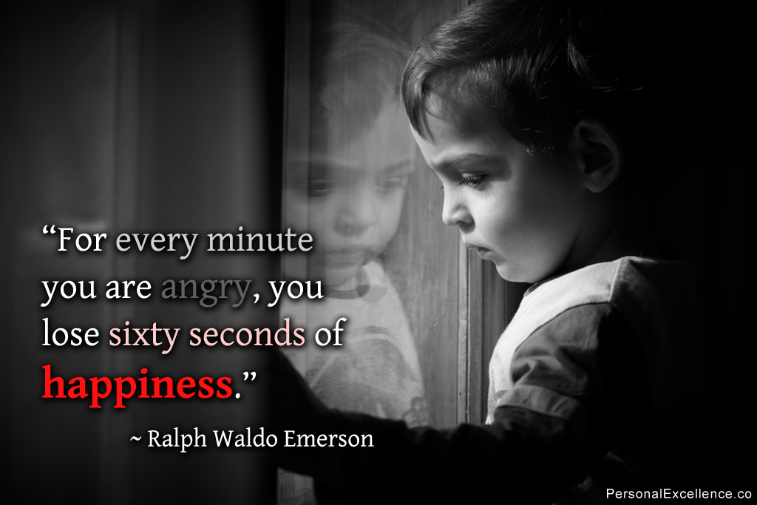

Forgiving is easier said than done, of course, no one says it will be easy and it really does take time for everyone’s unique circumstances. Sometimes being angry can serve us, but when we allow ourselves to be eaten up by it, it really does become a consumption of quality life-the life you’re meant to live.
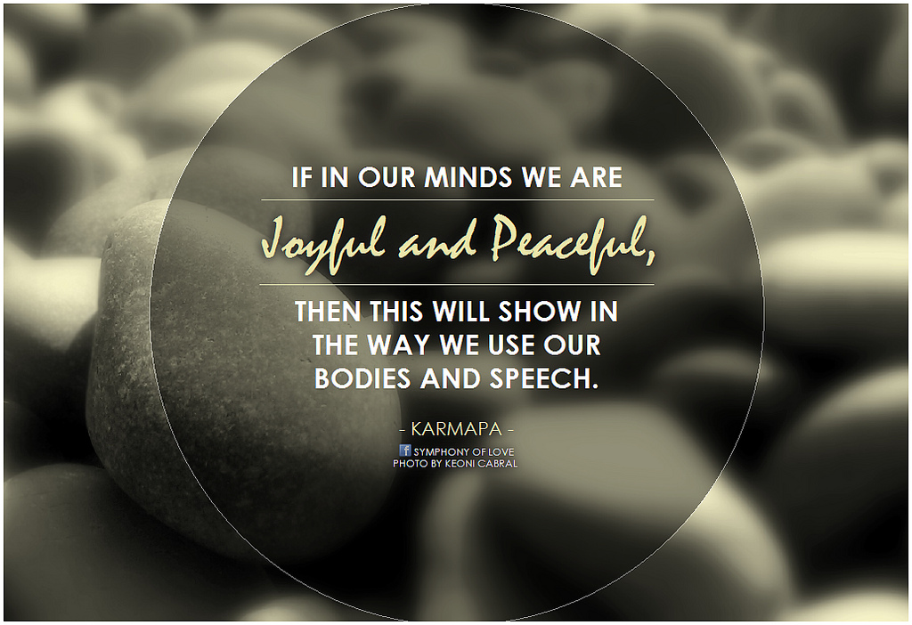
Click the image for “Jesus Loves Me” by Chris Tomlin.

Forgiveness equals freedom, joy, peace, and abundance! Being patient with yourself is a must in this process, but we have a model, not just anyone, but the King of Kings modeling for us the greatest power of all, the greatest love of all, the greatest mercy of all-Forgiveness! He died for us, in our humanness, for all sins, all different types, and all different degree! No one is excluded from His Mercy...No one...there is nothing you could do to change His love for you! We all make mistakes, have good intentions, but fail because we are weak (Matthew 26:41), but He still loves us all so much-even those that feel most unlovable or like a beast.

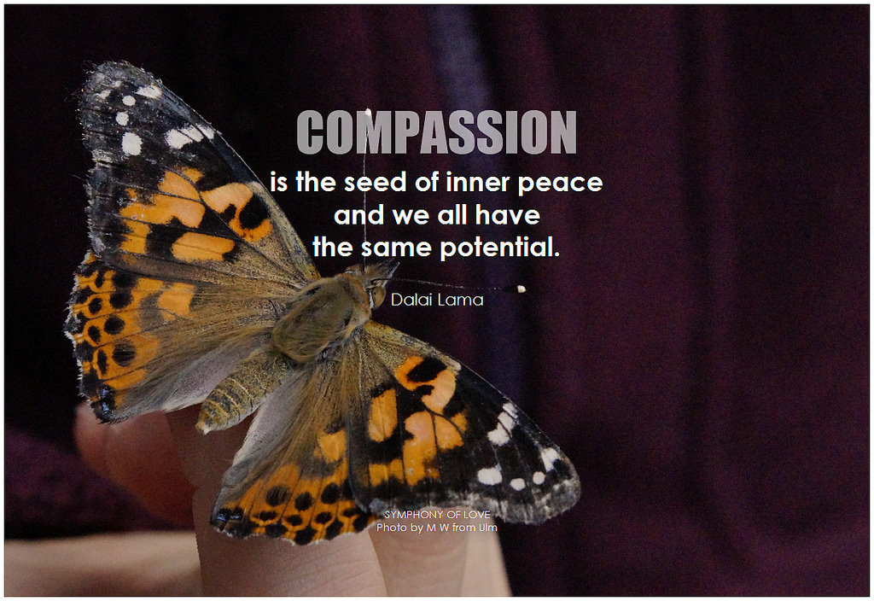

What does this mean for you? Even the beast that hurt and betrayed you is worthy of Forgiveness-not for any other reason than that he/she is a child loved by God, forgiven by God. He expects us to forgive, be tolerant, and merciful too! (“Our Father” and “Works of Mercy”). What about you? We are not always easy on ourselves. We are often the hardest on ourselves and beat ourselves up!! Can you imagine if God didn’t have compassion on us? I don’t want to imagine that! I do want to imagine that I could forgive someone not just because they deserve it and it’s the right thing to do, but because it frees my soul. Our souls were meant to live in harmony, rest, joy, kindness, compassion, generosity, etc (Gifts of the Spirit) so that that abundance that we so strongly seek after can be ours. It is in the freeing of our anger, resentment, and bitterness, that joy, laughter, and happiness can come in and take over! Your soul has healed and been reborn in joy! Love yourself! Forgive yourself! Everyday is a new beginning-He always wipes the slate clean! So Love Yourself and set Yourself Free of what is holding you back to a more peaceful (anabolic- building) life where you can thrive and live in abundance!! Will it be easy? Of course Not! With prayer, patience, and a support group of anabolic teammates, you can do it-Remember, everyday is a new day, the sun rises on your soul to shine!
Again, I thank you for entering into this time with yourself and digging deep! Feel free to visit my website www.findinggodspeace.com or email me at gina@findinggodspeace.com for questions or opinions!

You are loved no matter what-Love yourself too-You are worth it, we all our, for He died on a cross for the love of us!!

God Bless!
At the Cross-Chris Tomlin
