Online Courses
“Is the OUR FATHER really meant to help us in our DAILY LIVING?
3 Part Series
Part 3

Welcome to our complimentary course on the Our Father and how it really is meant to help us live out our daily lives…

Hello and welcome back. I am so delighted that you made it this far in experiencing the “Our Father” in a new light. I ask that in this last part of our 3 part series, you continue to remember you are inviting Christ to enter into this passionate and intimate time of learning with Him. When you love someone, you want to know all there is to know about them and visa versa. You are doing a great job of strengthening your relationship with Christ. This last part will focus on “Forgive Us Our Tresspasses as We Forgive Those Who Trespass Against Us”, “Lead Us Not Into Temptation, But Deliver Us From evil”, and “For Thine is the Kingdom, Power, and the Glory Forever and Ever. Amen! Enjoy...

And Forgive Us Our Trespasses as We Forgive Those Who Trespass Against US…Forgiving never seems easy when it is someone that we really loved that hurt us, or when the hurt is so deep that it becomes hard to breath. It would be easy for us to say that there is now realistic way to forgive and forget when Jesus Himself couldn’t forgive, or that God never sent His ONLY BEGOTTEN SON to be born incarnate, live, love, and serve obediently so much that He died on a cross for the forgiveness of OUR sins…it would be easy to say it is impossible to forgive; however, we simply cannot say either of those things because He did in fact forgive those whom persecuted Him, and was in fact born to be our Savior, yes, He SAVED US FROM US! He made new and complete what we cannot do in our humanness. Therefore, He gives us abounding gifts and graces to aide in this area that’s difficult for most-to forgive and ask for forgiveness to let free, and heal. Resentment and pain just break down our bodies, minds, spirits, energies and the like; eventually we won’t be able to recognize ourselves anymore-but through the cross we are asked to forgive for our peace, inner strength, and our own forgiveness.

And Lead Us Not Into Temptation, But Deliver Us From evil…There are no problems, but opportunities or challenges all around us. We need to learn to discern which opportunities we could learn from the best and how they can serve us in our daily living vs. being the effect of our choices. It isn’t easy to always live a life with perfect intention for “the spirit is willing, but the flesh is weak”- Jesus knows us inside out and knows what we are and aren’t capable of doing. We need to use our inner logic/voice, intuition, gut-feeling, conscience whispering in our ear (sometimes very loudly) to avoid what might lead us to be tempted, not to put ourselves in a situation where we might feel weakened in the senses and fail to have self-control. This isn’t just adults that suffer from this, but teens as well-gossip, social media slang, posts, etc. If instead we used our actions based off our negative thoughts and emotions, but rather saw opportunities in life for real growth and knowledge, perhaps we would harness our energy into something beautiful-prayer, kindness, service, compassion, and forgiveness. Let us walk the talk we say well walk! Evil is all around us, but has no power to consume us-may we only be consumed with the fire of the Spirit-call on Him and He will deliver us!

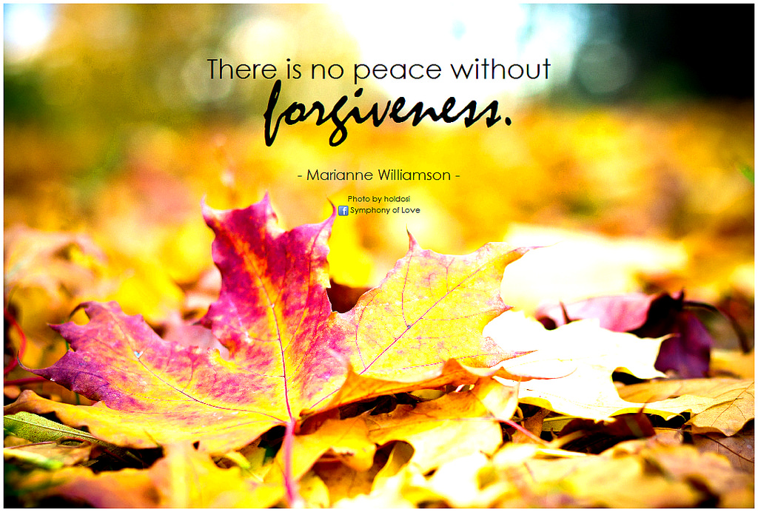

For Thine is the Kingdom, Power, and the Glory Forever and Ever. Amen! His truly is the Kingdom, the Power, and the Glory forever and ever, but it doesn’t end there. It is not just His, but Ours too-for He made us to share in all His wondrous works, love, and divinity of our perfectly designed humanness. It is all within our reach by our daily doings, our daily living, everything is a reflection for Him. We are to and should exult His Glorious love and power, for He is God Almighty!
Some questions to ask?
How do I view my daily living? How does this prayer reflect who I really want to be and how can I make it happen? How does Forgiveness work for you?
How might you feel if you allow forgiveness to be a part of your life?

I hope you have truly been able to reflect on the words of our Jesus and will walk away feeling refreshed and enlivened to live your life with purpose and passion so that Peace and Joy will be Yours!!
Feel free to visit my wesite at www.findinggodspeace.com or email me at gina@findinggodspeace.com for questions or opinions!! I know that anyway to decide to talk to God will made perfect in Him, He’ll guide your heart in the right way!! God Bless!!

