Online Courses
“Is the OUR FATHER really meant to help us in our DAILY LIVING?
3 Part Series
Part 2

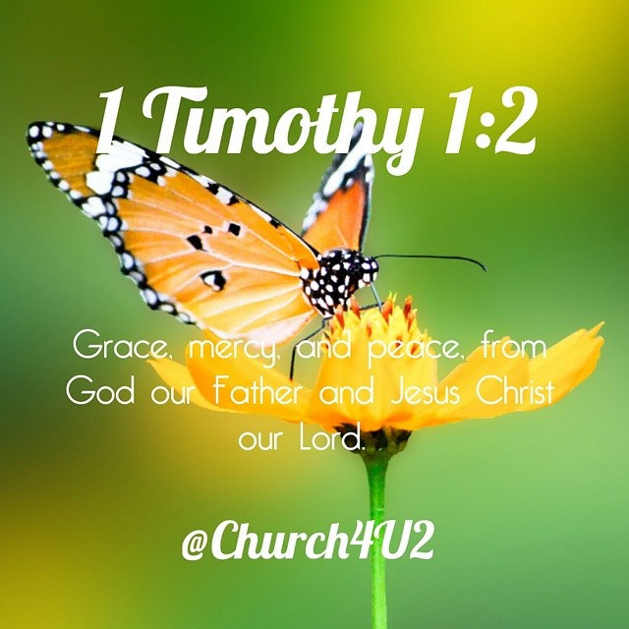

Welcome to our complimentary course on the Our Father and how it really is meant to help us live out our daily lives…

First off, welcome back to learning and renewing your faith with the “Our Father”
God Bless you today and let’s take a look, a close look, unto what we have known forever…

In our second part series, we will examine “They Kingdom Come”, “Thy Will Be Done on Earth as it is in Heaven”, and “Give us this Day our Daily Bread.”

I know you are ready for this next part and open to new ideas of peace and joy as they enter into your life!
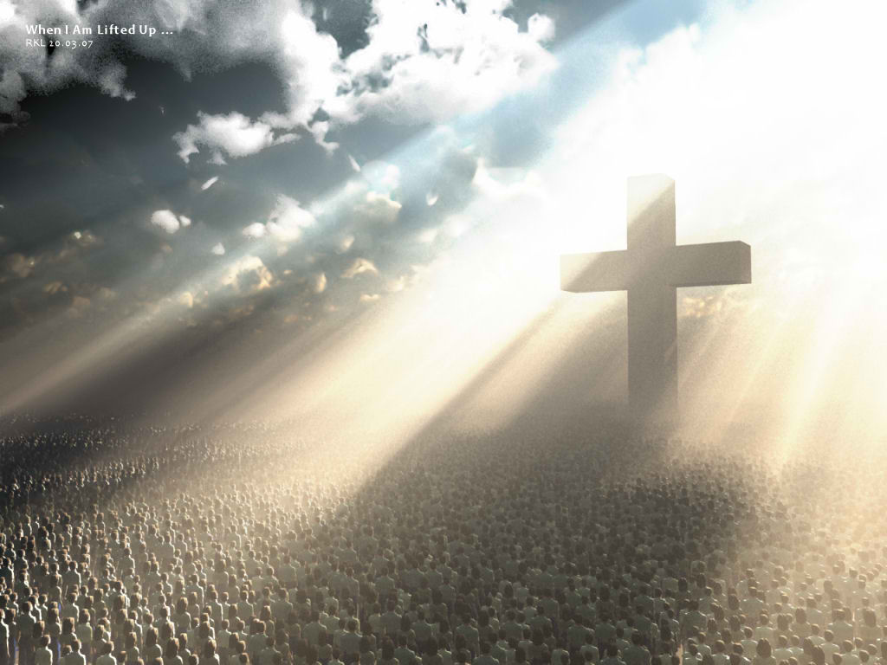

Thy Kingdom Come…The Kingdom of God is at hand….We are the participants of its arrival. We learn that we must do our daily jobs in bringing about the Kingdom of God right here on earth right now! Any time we love, share, put others before ourselves, or simply feel moved with compassion we are compelled to be in wonder and awe of all that is good and connect with all that is around us. We are all interrelated and learn that all that we do has an effect on everything around us (good and bad). This means that we are responsible for the coming of the Kingdom! Isn’t this wonderful, (in the words of Walt Whitman, 1900) “that you are here-that life exists, and identity; That the powerful play goes on, and you contribute a verse.”
How true is this statement? The play of life goes on and we are the actors of life making each present moment count-right here, right now-the journey of life is life itself-let it give glory to God to help Thy Kingdom Come!

Thy Will be Done on Earth as it is in Heaven…His Will, not ours…I know a person’s natural response would be, His will? What about me? Yes what about YOU? Made in His image and likeness to glorify Him-He designed us so unique and special. Most times we have desires and wishes and dreams…it is because they were first placed there by God. Our society might have skewed them a bit from the original design mixed with our need for fast simplistic methods to reach our end goal-our will does not seem like the Father’s. His love and wish for us to live perfect-we are all made perfect and by design were given perfect gifts, wants, and if we follow Him will see the perfect fruition of His Will be done.

Give us This Day Our Daily Bread...There are a couple of things to reflect on here. We are to totally rely on God for everything from spiritual guidance, graces, to daily needs being met like having food. Scripture provides us with knowledge on how God loves the birds, yet they don’t fret on where to get there food, but rather to have complete trust and reliance on Him for all things necessary. St. Therese said we were to be like children in our child-trust in God’s love and goodness. Another thing to think about is the Host, the greatest Sacrament of love and self-sacrifice….how we are so truly blessed that He is ever present in our Eucharist to provide us with life and nourishment-for there is no way, but through Him. Not only do we think of the blessed sacrament, but the Living Word of God as well whether in scripture, daily devotionals, prayers, meditations, or quiet times with Him to hear His voice for He always speaks to us-always-usually in ways we least expect-but ever present.

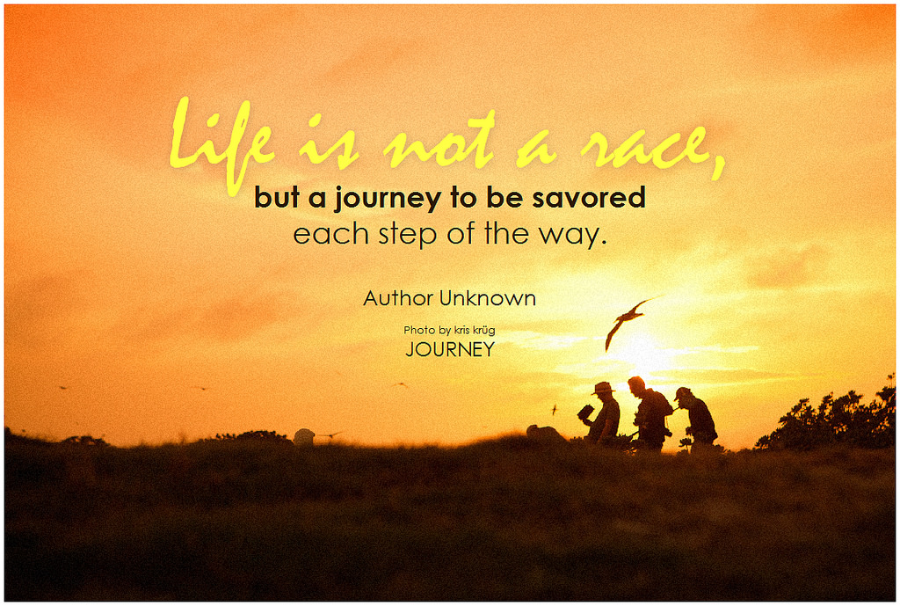

Some questions to ask?
How do I view my daily living? How does this prayer reflect who I really want to be and how can I make it happen? How is this part different than the first part? Do I feel more renewed? Does this all make sense? How do you see yourself living this out? What is my source of daily bread? The next and final part of our 3 part series is Lead Us Not Into Temptation, Deliver Us From evil”, and “For Thine is the Kingdom, Power, and the Glory Forever and Ever. Amen! God Bless and Enjoy!!

I hope you have truly been able to reflect on the words of our Jesus and will walk away feeling refreshed and enlivened to live your life with purpose and passion so that Peace and Joy will be Yours!!

Feel free to visit my wesite at www.findinggodspeace.com or email me at gina@findinggodspeace.com for questions or opinions!! I know that anyway to decide to talk to God will made perfect in Him, He’ll guide your heart in the right way!! God Bless!!

