Online course on “I am loved in my Humanness, Flaws, Sins, and Lack of Faith, and still He raises me to do Good Works!”
2 part series

"Thy Will Be Done" song
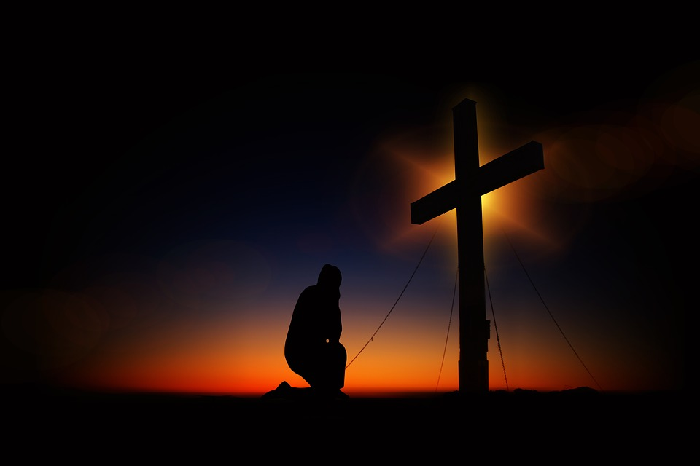

Welcome to this second part of the online course, I hope it finds you well, and that you are ready to continue exploring who you are and how much you are loved and valued…

Last time we ventured into the live of Peter, our 1st pope and rock to which the Church was build. Just as he was amazing, we saw how he was also just like us...human! In in flaws, weaknesses, able to give into temptations, etc. However, with the peace of God, he was able to turn despair into greatness.

We will now look at our other great model/saint for us- St. Paul.

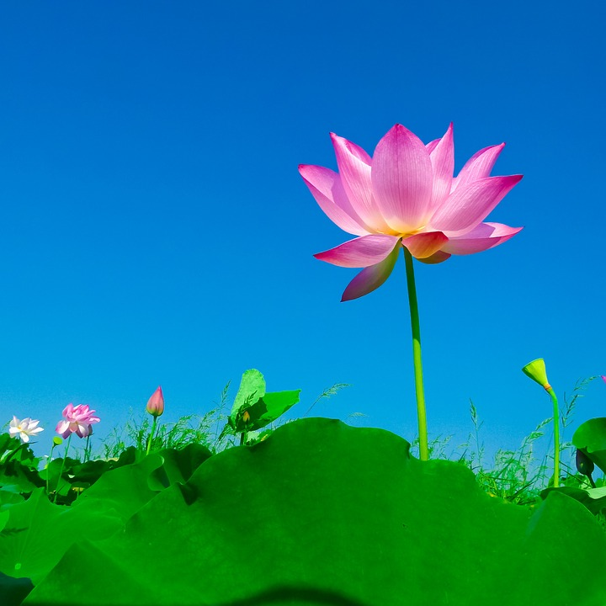

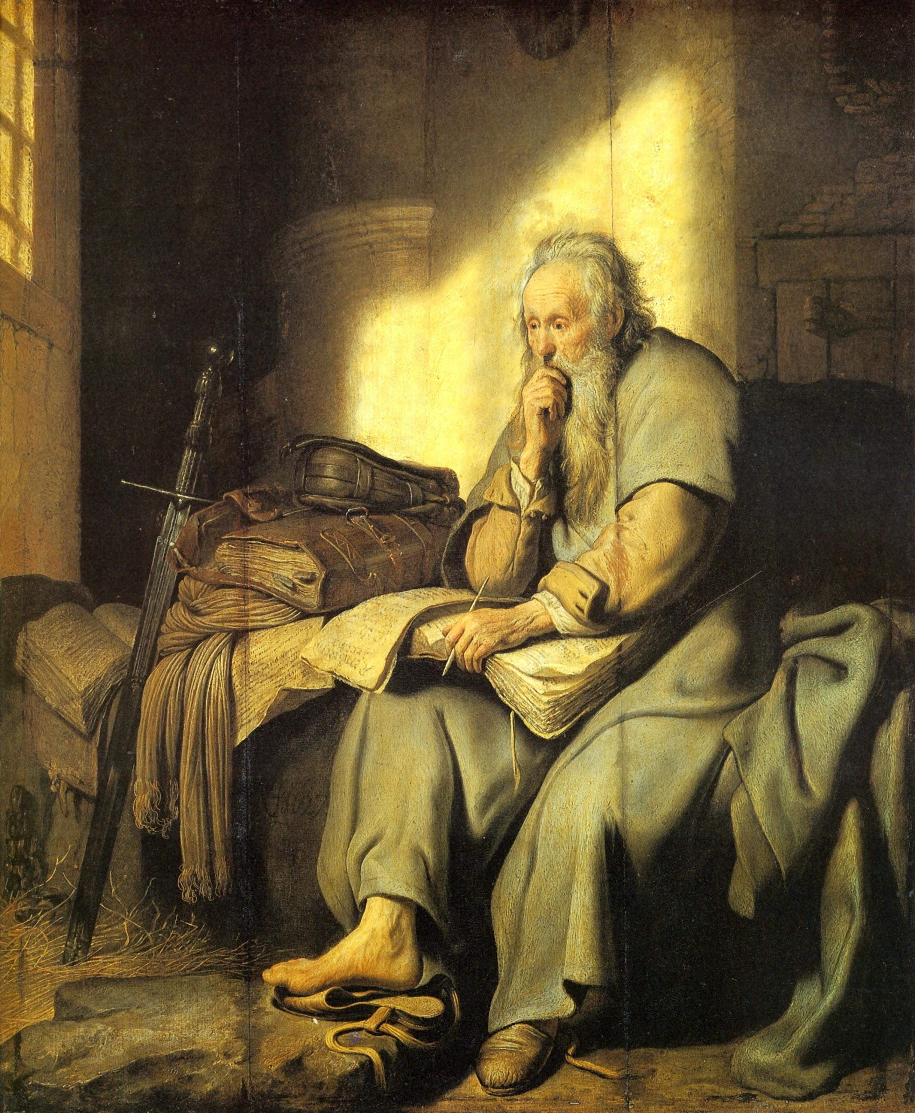

St. Paul’s story starts out as Saul, a Jewish Pharisee, the type that didn’t like Jesus or Christians, was often witness to Christian persecutions. On a road one day, he is blinded and suddenly see the “Light” revealed to him through Christ. He realizes what he has been doing, and what he should be doing….not against Christ, but living for Christ. Paul traveled great distances to spread the Word the God and even wrote letters to different communities about everyday living and how to live accordingly. He taught that faith, hope, and love are important virtues, but that love is the greatest of all. Being pure love is to be like Christ-it exemplifies what he describes as the fruits of the Spirit. Even when Paul was in jail, he wrote about happiness. How often do we feel imprisoned about life and worry that happiness can never be ours?

It is perfectly normal to want to be in “perfect” circumstances to feel happy or know happiness. In reality, happiness and joy are a choice we make to respond to our surroundings. It is a practice to which we decide to view things differently. For example, if we perceived that God has allowed certain things in our lives to take place so that it makes us stronger and better, perhaps we too could allow ourselves to see more joy and peace in the works. Like that of a potter’s hand, molding and remolding until his object is perfect, God molds and remolds us to get us to perfection in Him. From our pains and trials comes great compassion, wisdom, and strength. From these depths God raises us up to do great things-things we alone couldn’t do.

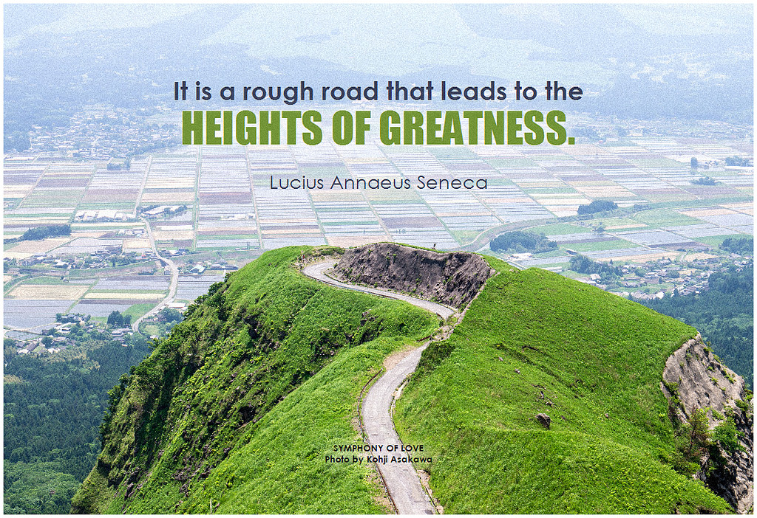

Think about a time in your life when you were able to really succeed at something or accomplish something difficult? Was there a lot of hard work put into it? Did it take time, tears, and “sweat”? Maybe not, sometimes, things come easy or naturally for people, other times -it takes some diligence and lots of determination. In either case, we need to trust the process, the process of following God’s will for us, based on unconditional love and divine greatness for our lives. No matter the degree of what we do, it is in greatness. These great works are all for love of us because He restores what was once broken into something new and magnificent so that we might have all the peace, joy, and abundance in the world!!

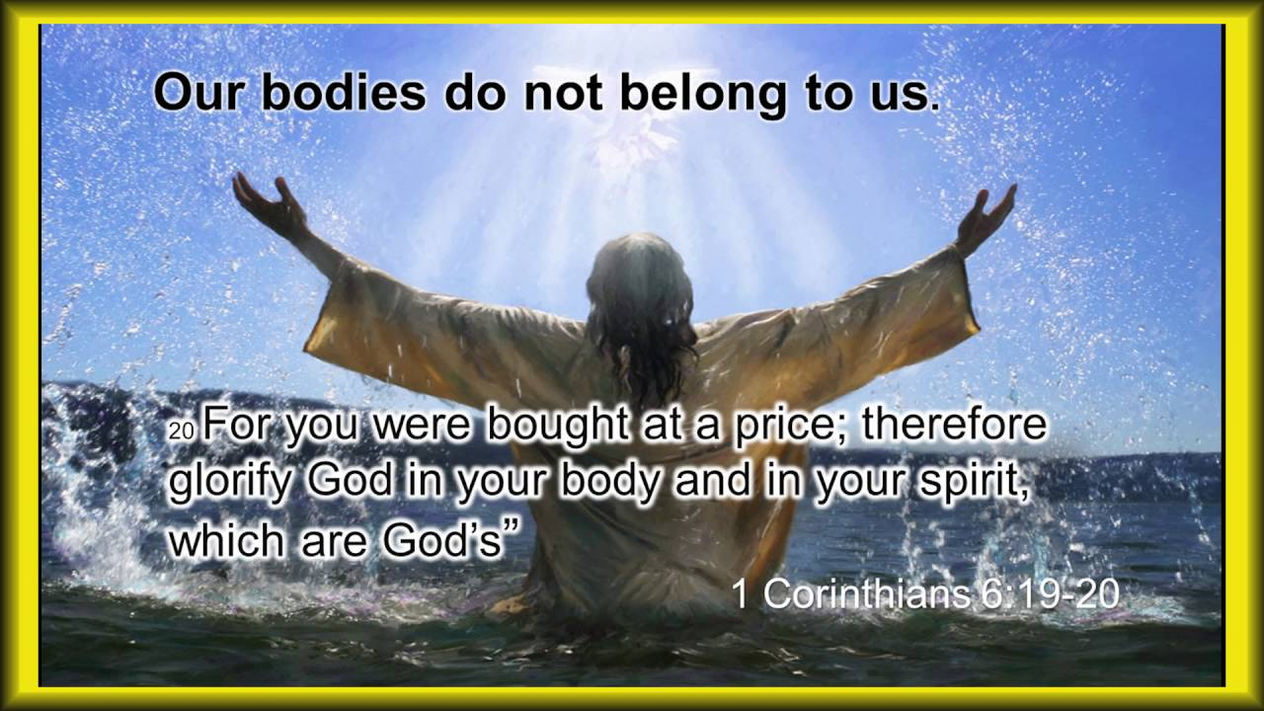

I hope you have enjoyed our time together and have taken some new insights and thoughts to help you in your quest for peace and joy. I invite you to visit my website at www.findinggodspeace.com or email me at gina@findinggodspeace.com for questions or opionions. God Bless-’till next time!!

