Online course on “I am loved in my Humanness, Flaws, Sins, and Lack of Faith, and still He raises me to do Good Works!”
2 Part Series

"Thy Will Be Done" song

Welcome to the 1st part in the online course, I hope it finds you well and ready to explore who you are and how much you are loved and valued…

It is really a great story of Peter and Paul when you think about it.
Peter, a regular fisherman, hot tempered and impatient, was going about his regular duty when Jesus asked him to follow Him-and that he did. He left everything behind and became not only one of His devout followers, ones of His closest friends. We know the familiar Holy Thursday story where Jesus goes to bend down and wash the disciples feet and Peter states that He shouldn’t do that because He is their Master-well, Jesus knowing Peter replies back that unless people learn that no master is greater than his servant and likewise the reverse. He also stated more importantly He came to serve, not be served and likewise if you do not do as I do, you will have no part of Me...This shows that we are meant to take care of each other, that no one is above or better than another and that to enter into Christ we too must imitate in His ways of lowering ourselves before others. When Jesus goes to pray in the garden, Peter and the others are asked to stay awake, keep watch, and pray.
Three times Jesus comes back to find them sleeping...then when Jesus is arrested, Peter grabs a soldier’s sword and cuts the offender’s ear off in haste-only to be healed by Christ.

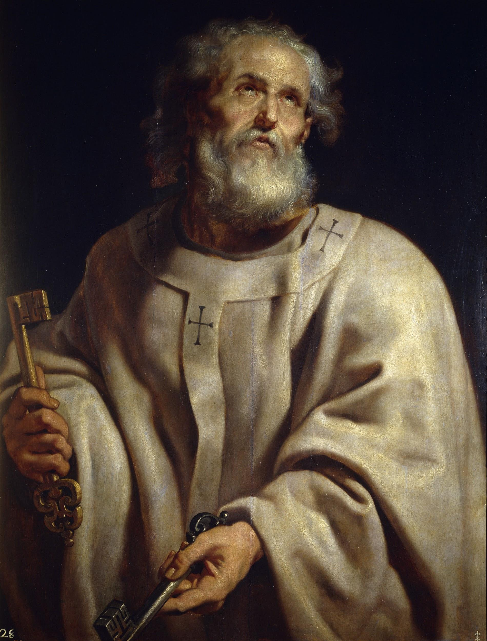

Peter, at dinner, had promised not to turn or deny Christ, but would go to the death for Him when confronted by Jesus about him denying Him three times. Peter, as we know, does as Jesus predicts, and denies Christ, his friend three times and runs off because he was ashamed. He was not present for friends suffering or death. In Peter’s flaws and humanness, Jesus would understandably be upset or resentful towards him when he resurrects. However, when Jesus see Peter and the other disciples, His words aren’t of malice, or contempt, but rather love and forgiveness, He states, “Peace be with you!” All is forgiven and now let’s move on; We have work to do!! Talk about a fresh start...Jesus always uses ordinary people to do extraordinary things...We could name many, many more whom thought they weren’t up the task, or too unworthy, but God’s love, grace, and purpose prevailed.

Next time we will discuss another great example of how someone that made relentless mistakes ended up being one of the most influential evangelizers ever known. (One of my favorites!!)
Until then...feel free to visit my website at www.findinggodspeace.com or email me at gina@findinggodspeace.com for thoughts or questions!!

I pray and know that you will see too how Magnificent you really are!!

