Online course on “How can Knowing and Living the Beatitudes make ME Happy and Joyful?”
8th part of the 8 part series.

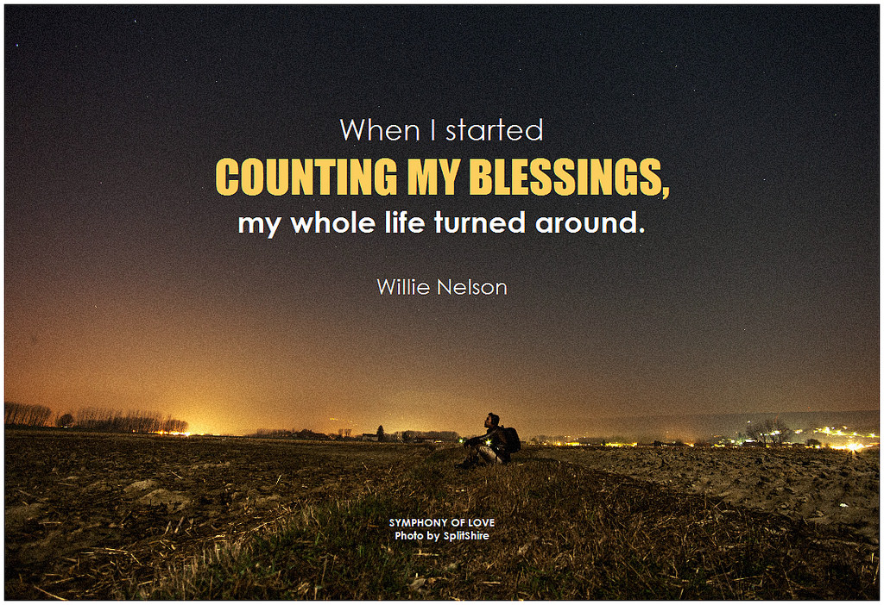

Welcome back to our last part in this amazing series/journey on finding joy and peace in your daily living by knowing and being a witness to the 8 Beatitudes.

An overview of our time together: THE EIGHT BEATITUDES OF JESUS

"Blessed are the poor in spirit,
for theirs is the kingdom of heaven.

Blessed are they who mourn,
for they shall be comforted. We will look at each one separately
Blessed are the meek,
for they shall inherit the earth.

Blessed are they who hunger and thirst
for righteousness,
for they shall be satisfied.

Blessed are the merciful, We will explore ways to live them out
for they shall obtain mercy.

Blessed are the pure of heart,
for they shall see God.

Blessed are the peacemakers,
for they shall be called children of God. We will look at how this feels for you

Blessed are they who are persecuted for
the sake of righteousness,
for theirs is the kingdom of heaven."

Gospel of St. Matthew 5:3-10

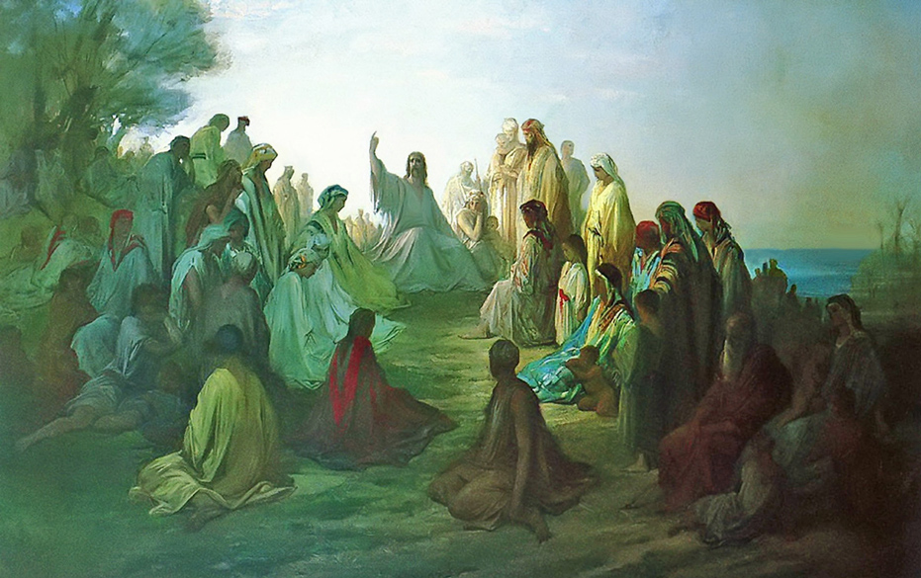

“Blessed are they who are persecuted for
the sake of righteousness,
for theirs is the kingdom of heaven."

Living this Beatitude out is difficult, but easy at the same time. It is hard for those that find the world’s material items to be the utmost importance. They would rather devout their time and energy to those causes than the simple and “un-fancy” things seemingly associated with God. It is not so hard, though, (notice I didn’t say easy) for people who are poor in Spirit, humble and meek, and pure of heart. For those that are passionate and are aflame with love and faith in God. These people will defend regardless of ridicule, judgement, and pain. These people are called to be different. No one ever said that following Jesus, or carrying your cross, was glorious, easy, popular, well-regarded, or rewarded in this life. In fact quite the opposite is true. Those that are bound to follow in His footsteps are likely to be make fun of, judged, snickered at, and mocked. This doesn’t just occur globally, but within nations, towns, communities, and families. Think about it, this was just as Jesus was treated when He came, professed, and then died for us. How does this make you feel? How can this allow you to transform your feelings, thoughts, words, and deeds? How can you learn to renew your commitment to Christ even if it isn’t always easy or condoned?
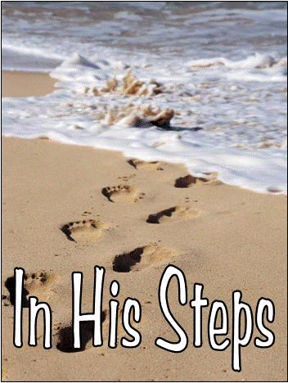

What does mean to you? Does this challenge you? What instance can you think of when you did in fact follow in His footsteps? When was there a time you didn’t. Be gentle to yourself, you are human, but you are profoundly loved. He came so that we might learn how to live and live abundantly. He doesn't want us to suffer or be without, but rather defend what is right, so that the righteous might thrive and live on forever.

Jesus says that He found pain in “Lukewarm souls” -this is hard to understand at first, but once we learn that these people are all around us- it explains a lot. Bad are bad, good are good, but what about the complacent, the apathetic, the indifferent, the bystander…

Elie Wiesel quotes “The opposite of love is not hate, it's indifference. The opposite of art is not ugliness, it's indifference. The opposite of faith is not heresy, it's
indifference.”
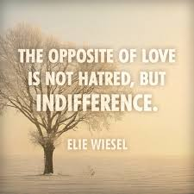

We see this indifference, I don’t care, glad it’s not me, let someone else deal with it, attitude all the time-bullying at school- bystanders doing nothing. We teach our children to be upstanders. Get involved, help others -Works of Mercy”- instruct the ignorant, warn the sinners, etc.

How we stand against the grain, go against the crowd, be different, active and not passive in our faith, and evangelizers? (Actions speak louder than words, but our intent is the core of who we are).

How can you live this idea out?
How can you make this your call to action today? Tomorrow? Not necessarily all the time, but start to seek it even a little bit a time. Are you willing to further explore how this can look and work in your life?

I am here to partner with you on your journey to finding God’s peace within, w you were designed to be, let your gifts come to life, live in abundance, and allow peace and joy to be yours!!

Thanks so much for diving deeply into this 8 of 8 part series on the Beatitudes. I know you care about your life and value how truly precious you are to Him!!

Thanks for joining us and hope you took a special value and wisdom from this experience! God Bless and May Peace and Joy be Yours!

Please visit my site at www.finddinggodspeace.com or email me at

​ Gina@findinggodspeace.com for questions or thoughts!!

