Online course on “How can Knowing and Living the Beatitudes make ME Happy and Joyful?”
2nd part of the 8 part series.

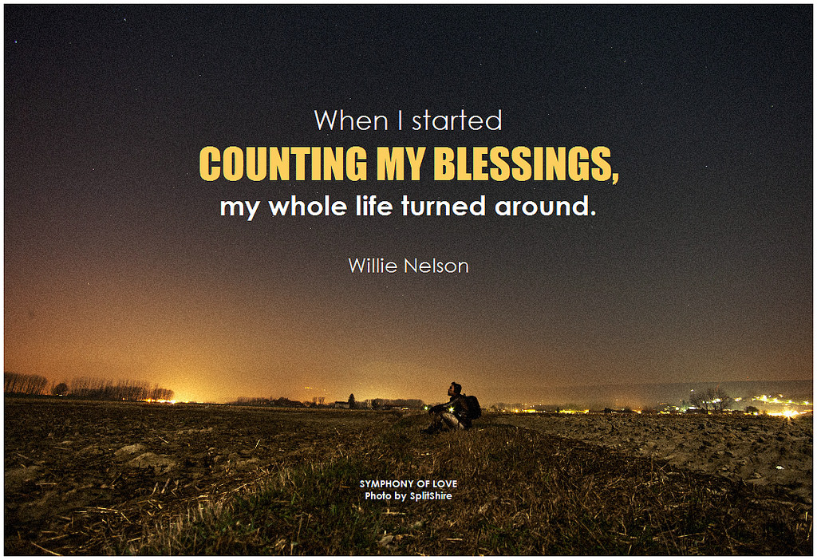

Welcome back to our second part in this amazing series/journey on finding joy and peace in your daily living by knowing and being a witness to the 8 Beatitudes.

An overview of our time together: THE EIGHT BEATITUDES OF JESUS

"Blessed are the poor in spirit,
for theirs is the kingdom of heaven.

Blessed are they who mourn,
for they shall be comforted. We will look at each one separately
Blessed are the meek,
for they shall inherit the earth.

Blessed are they who hunger and thirst
for righteousness,
for they shall be satisfied.

Blessed are the merciful, We will explore ways to live them out
for they shall obtain mercy.

Blessed are the pure of heart,
for they shall see God.

Blessed are the peacemakers,
for they shall be called children of God. We will look at how this feels for you

Blessed are they who are persecuted for
the sake of righteousness,
for theirs is the kingdom of heaven."

Gospel of St. Matthew 5:3-10

“Blessed are they who mourn, for they shall be comforted.”

This Beatitude has many purposes or rather many facets to which we will discover. In order to live it accurately, we must understand what it is, how to live it, what it looks like, and how this all makes you happy and peaceful!

St. Gregory states, “the more one ascends in meditation of Divine Truth, Beauty, and Goodness, and then realize the poverty of human nature, man can only be left in sorrow. When one contemplates that we were made in the image and likeness of God and lived in Paradise, the Garden of Eden, and compare that to our present state after the Fall, one can only mourn our present condition.“ We mourn because we know we sin and offend our God Who is good and deserving of all our love, and because we are compassionate and share in others’ suffering. We mourn for the injustice and how others long for peace and to be found. We mourn because our hearts long for our Maker to which He has innately planted with in the desire to know Him.
The Maker by Chris August

In mourning, we desire action to move forward, to change what the present condition is to make it better for us and those around us. This drives us to want to acquire peace and joy for all around us so that it pervades all over!

Now, how do we live it? We live it everyday… we all do things that we are probably not even aware we are doing because we are all inherently good natured people that want to be united with God the Father. When we act tenderly towards someone because they are hurting or in distress, that initial feeling is that of mourning because you want to make it right! Think about how that propels your actions...comfort, embracing, patience, kind words and deeds. Wanting to make it better for them. That mourning allows for you to become comforted as well because internally you are aware that you are helping others and will feel that joy and comfort back from your Father because you have shown kindness and compassion to those in need.

Blessed, meaning happy, are those that mourn for others for they too seek the face of God! Being mournful about one’s self is another type of mourning that we are called to participate in. In this way we really contemplate who we are, how we live, what it is that we are doing, and how we can grow and improve. We are not pathetic or miserable, wretched sinners, but in our humanness, sometimes we are forgetful, weak, anxious, hurtful, and indifferent. God knows all of this, loves us profoundly regardless of our human flaws, and yet still sees us as perfect, beautiful, and worthy of giving His life! Because of this contemplation, we feel discouraged, guilty, or sad that we have let Him down, or think about how we feel when we let others down. We also come to realize that we are not yet perfected in Christ-worthy to see Him face to face because of our mistakes and sins, so we mourn that we need to improve...this, again, allows for us to seek God in all we do so that we might one day be united with Him forever!

So what does this look like? Recognizing that guilt is ok...it is a monitoring device to look at our souls and see where we need adjustments and areas to improve on.

These feelings of brokenness can be transformed to new life, purpose, direction, and action to move forward. God makes them beautiful! We need to pray to Him so that we might strengthen our faith in Him, our relationship, our trust, and become more mindful of His Divine presence working in our lives for our benefit. We not let the feelings of mourning consume us, rather enkindle within our hearts, that new life can stem from these feelings and we can gain peace, happiness, and joy from Him!!

How does mourning make you happy? This is so because it brings about purpose, desire to seek God, time to trust and be intimate with our Creator, change our lives in a way that serves us and those around us, is in alignment with social justice for others, and honors are true Who and values!!

How do you see yourself living a life in this fashion? Does this sort of clarity seem to be engaging to you? How do you see your mourning turning into something for good? How much faith do you have in God that He can take and make your sorrows and transform them into glory?

How comfortable are you in believing this idea? Do you want to live in His peace?
How might you go about challenging your old belief system of being in control vs. letting God take over? Do you see how this can transform your life? Do these ideas make sense you your heart? Are you willing to further explore how this can look and work in your life?

I am here to partner with you on your journey to finding God’s peace with in, who you were designed to be, let your gifts come to life, live in abundance, and allow peace and joy to be yours!!

Thanks so much for diving deeply into this 2 of 8 part series on the Beatitudes. I know you care about your life and value how truly precious you are to Him!!

Can’t wait to see you next time for “Blessed are the meek, for they shall inherit the earth. “

Please visit my site at www.finddinggodspeace.com or email me at Gina@findinggodspeace.com for questions or thoughts!!
Until then, God Bless.

