E-Book for you…

Peace, Joy, and You
By: Gina Sannasardo

E-Book
This is a journey of self exploration, not just “another thing to do”….Sit back, relax, and invest some time for yourself and the life you want to live. Feel good about who you are and who you are becoming. God loves you for who you are no matter what has taken place in your life. His love is free and not earned. We are all so abundantly loved and given graces to lift us up in the midst of life. Think for a moment, what brings you joy and peace in your everyday life….if you feel you struggle with this question, then think about what could bring you peace in your everyday life__________________________________________________________________________________________________________________________________________________________________________________________________________________________________________________________________________________________________________________________________________________________________________________________________________________________________________________________________________________________________________________________________________________________.What does it take to have that peace you long for in your life?_________________________________________________________________________________________________________________________________________________________________________________________________________________________________________________________________________________________________________________________________________________________________________________________________________

Sometimes we forget about the joys of everyday living, and this might even include the everyday headaches, crazy and over scheduled events, meetings, extracurricular activities our kids might be in, chores, bills, let’s face it, the list goes on and on. There is one thing to remember: God is silently waiting at our hearts to embrace all our pains, sufferings, tired efforts, flaws, and all (Matthew 11: 28-30), but He and He alone will give us rest, and peace the world cannot offer on its own (John 14: 27).
How aware are you that you are loved, adored, special, unique, and what does it look life in your daily living?________________________________________________________________________________________________________________________________________________________________________________________________ ____________________________________________________________________________________________________________________________________
______________________________________________________________________________.
What does peace look like to you?__________________________________________________
__________________________________________________________________
__________________________________________________________________
_____________________________________________________________________________.

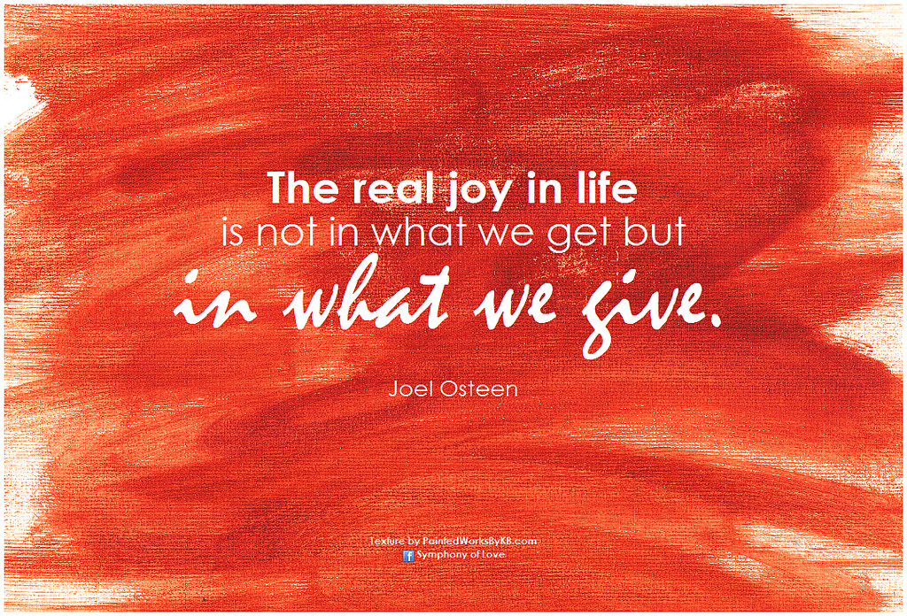

Describe what a joyous life for you would consist of?_____________________________________________________________
__________________________________________________________________
_____________________________________________________________________________
__________________________________________________________________
How can you incorporate this idea into your everyday lifestyle?________________________________________________________
__________________________________________________________________
_______________________________________________________________________________.

Jesus truly knows us best (Jeremiah 1: 5 and Luke 12:7). How amazing it is when we really sit back and realize He knows us inside and out, gifts and humanness, He has created each of us for a unique purpose and mission to be immensely happy in this life, and immeasurably happy in the next. He has given us the Holy Spirit to be our guide, advocate, and His divine presence to all the gifts He has given to us so that we might thrive and grow, live and laugh, and have peace and joy.
Paint a picture of a day where there is no anxiety, worry, fear, exhaustion, or sadness:______________________________________________________
_____________________________________________________________
______________________.
What can you do to make that vision a reality?_______________________________________________________
____________________________________________________________________________________________________________________________________
_________________________________________________________________
__________________________________________________________________________________.
On a scale of 1-10 how willing are you to make that happen 1 being the least effort and 10 the most.
1—2—3—4—5—6—7—8—9—10…….Explain why you chose the number you did________________________________________________________
___________________________________________________________________________________________________________________________________
__________________________________________________________________Now, LETS talk and find God’s PEACE, LOVE, and JOY for YOU!
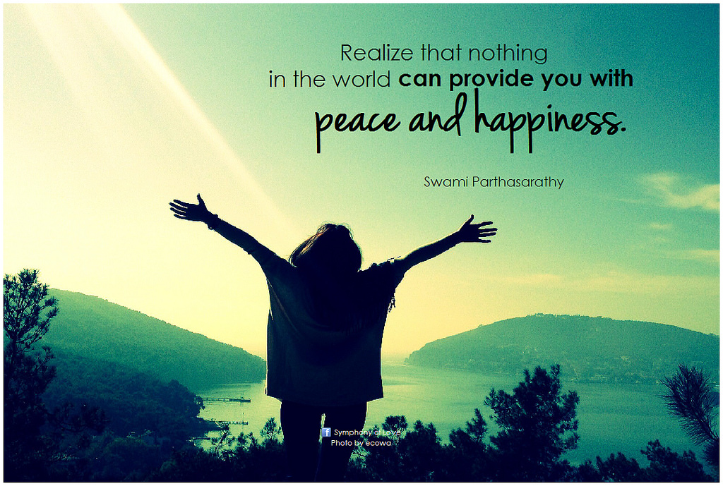

I hope you have enjoyed completing this E-book and found it to be enlightening and fun!! Please visit my website at www.findinggodspeace.com or emailing me at gina@findinggodspeace.com for question, opinions, or just to talk...God Bless!!

